(-3\*w)

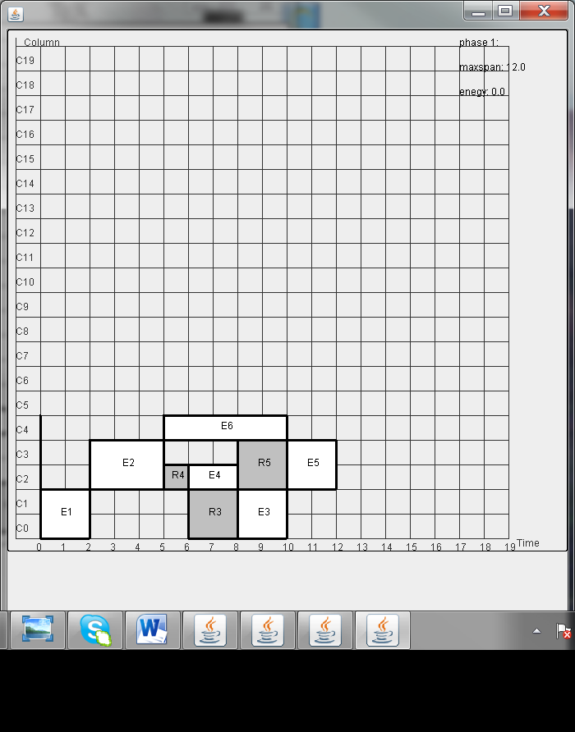

Exmaple 1- with leakage aware placement lk=20, est=4-39(est=lk)

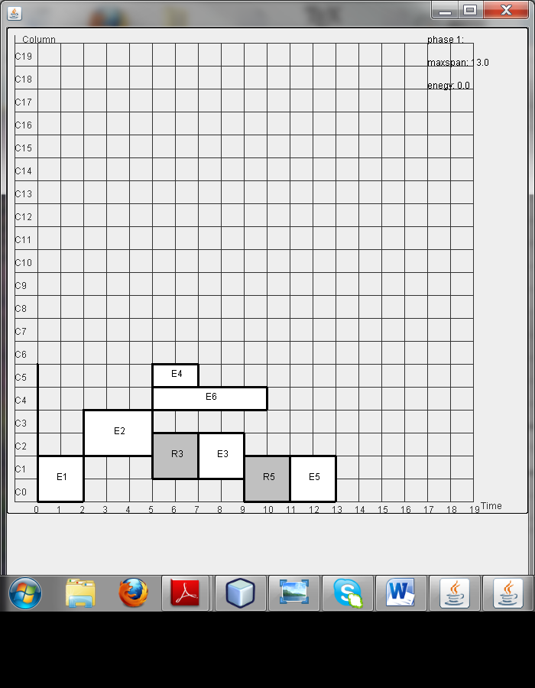

Exmaple 1- with leakage aware placement lk=20, est=0-3 (est=lk)

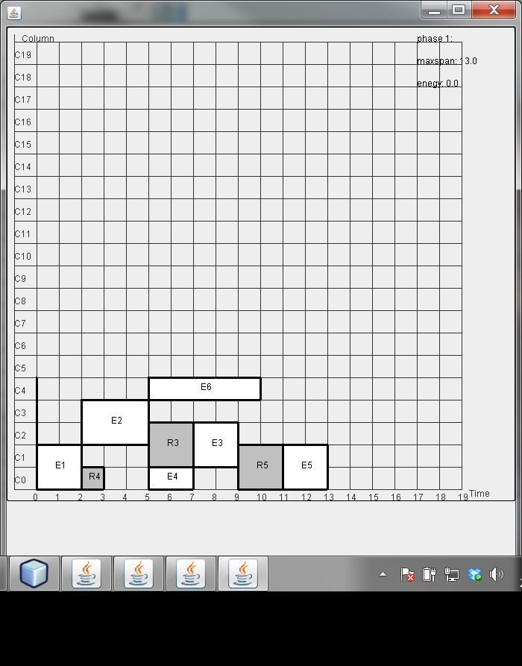

Exmaple 1- with leakage aware placement lk=20, est=40-60(est=lk)

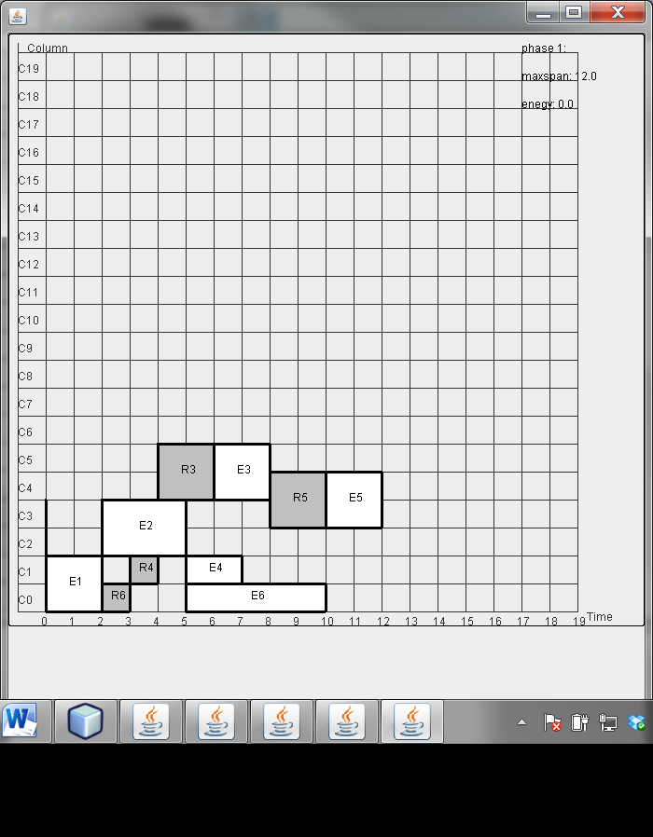

Exmaple 1- with leakage aware placement lk=20, est=60-96(est=lk)

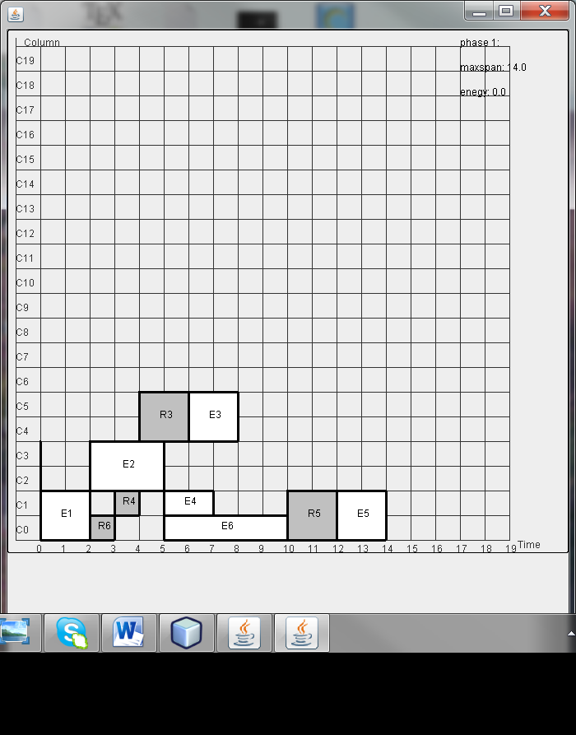

Exmaple 1- with leakage aware placement lk=20, est=98 -(est=lk)

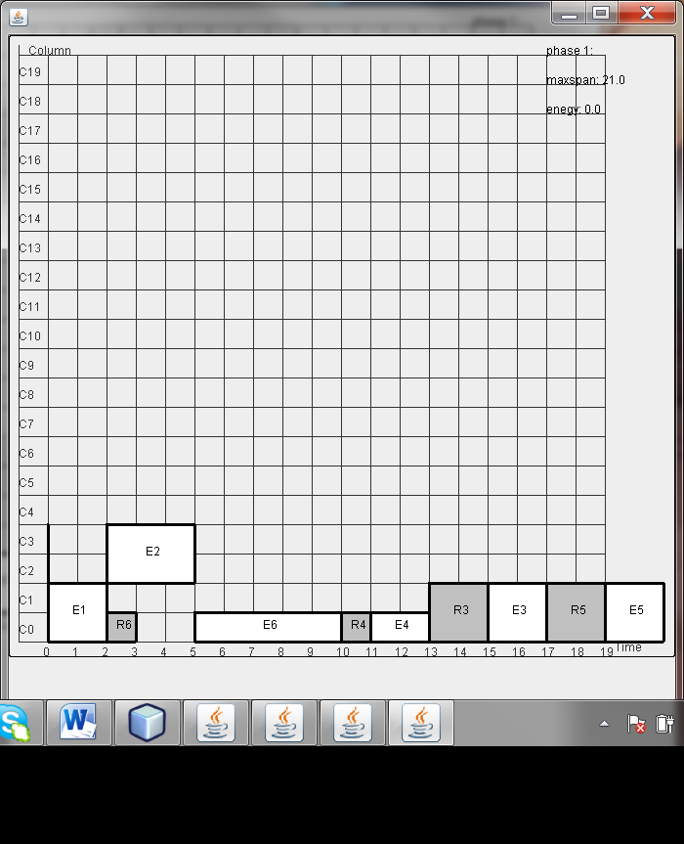

Exmaple 1- with leakage aware placement lk=20, est=210 -(est=lk)

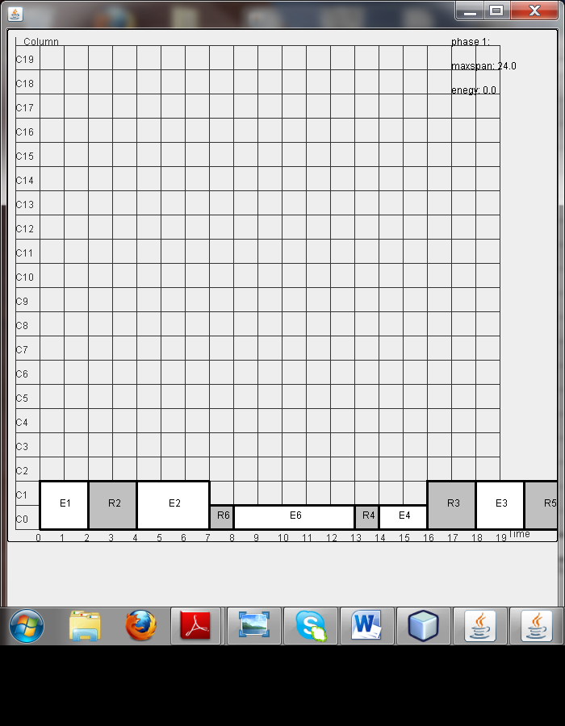

Exmaple 1- with leakage aware placement lk=20, est=310 -(est=lk)

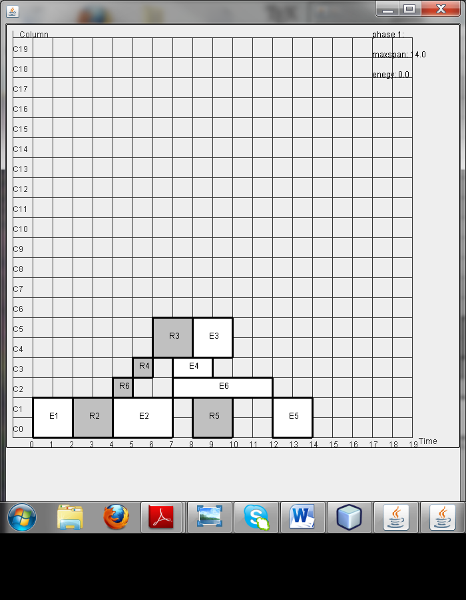

Exmaple 1- with leakage aware placement lk=0, est=1(est=lk)